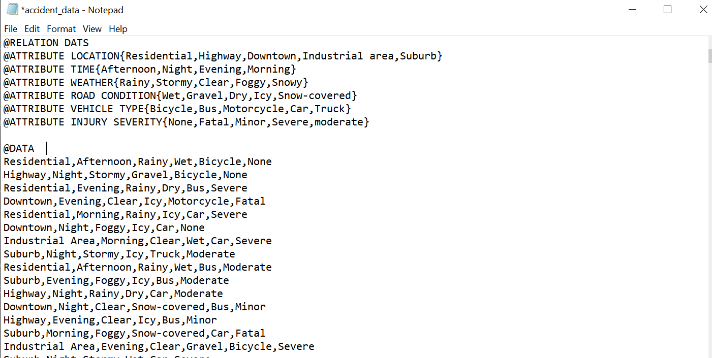

PREPROCESSING

LOCATION

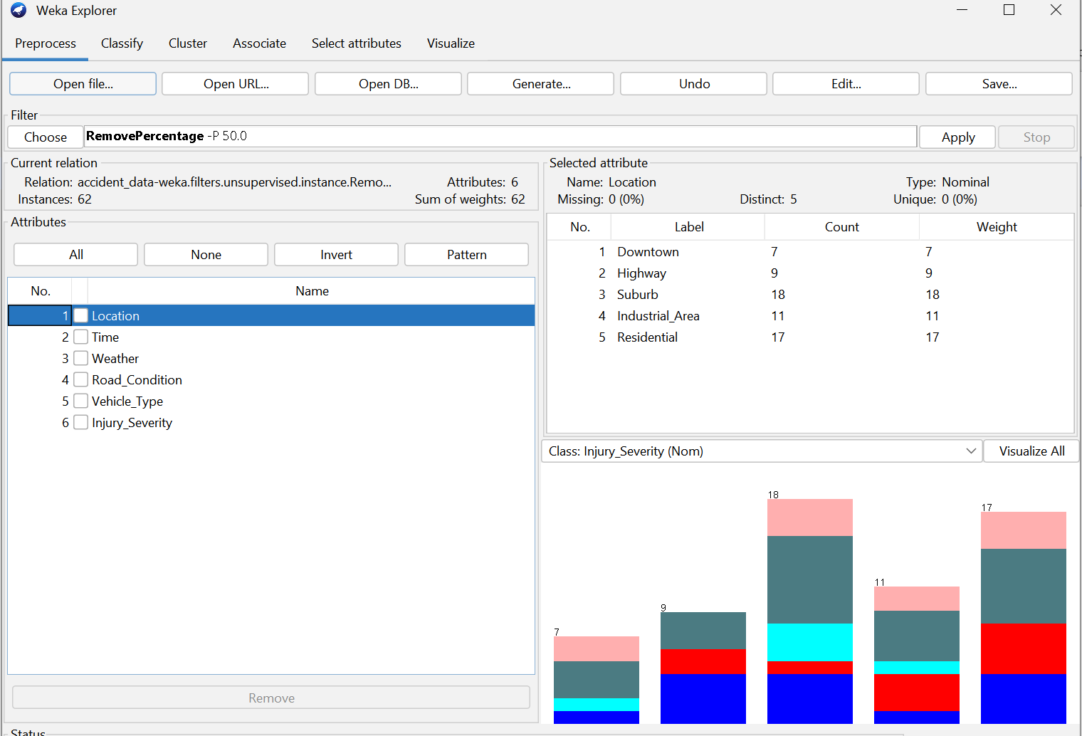

TIME

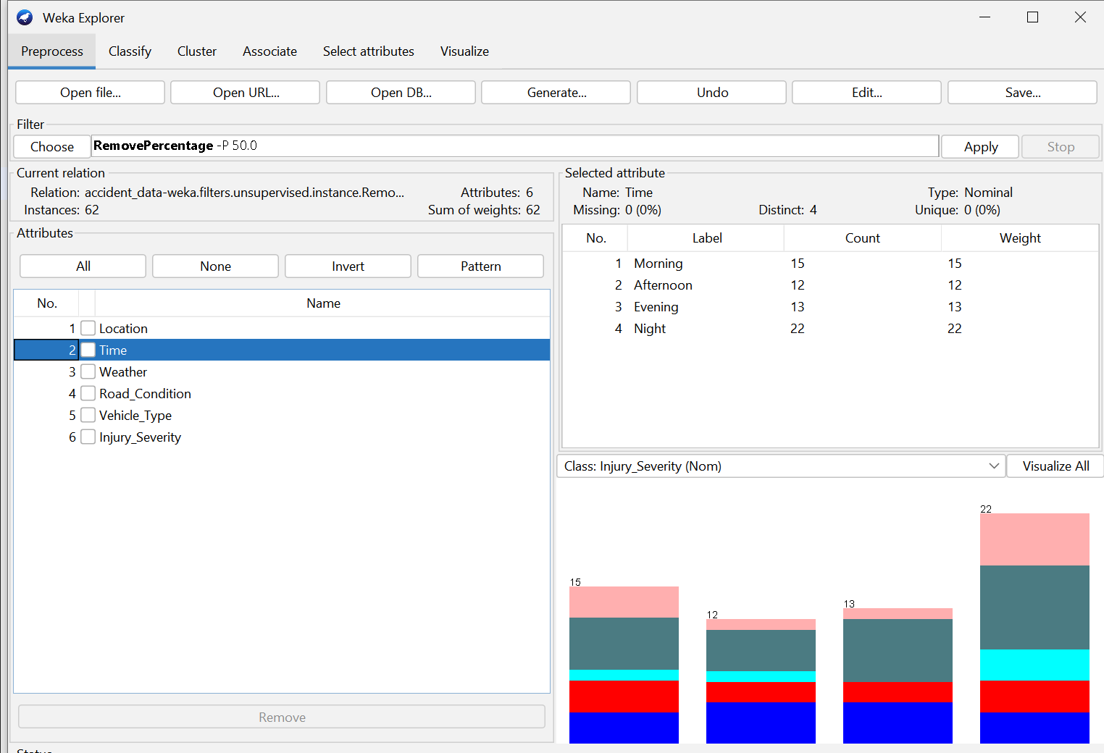

WEATHER

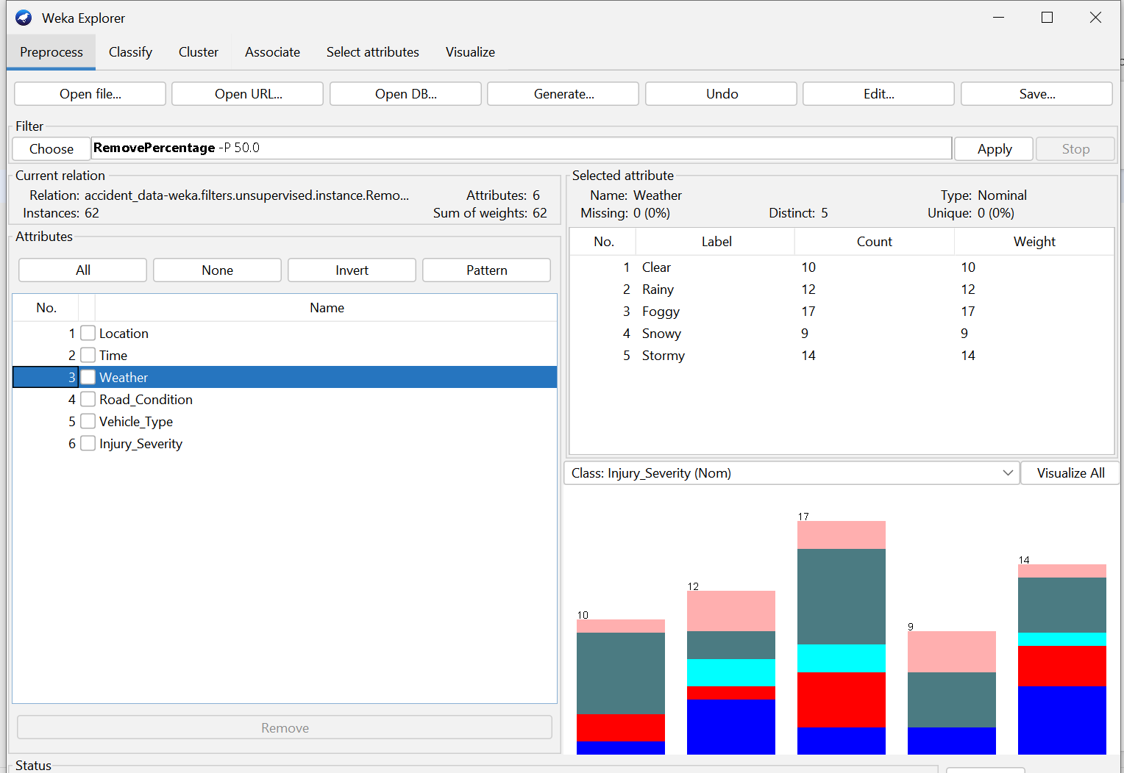

ROAD CONDITION

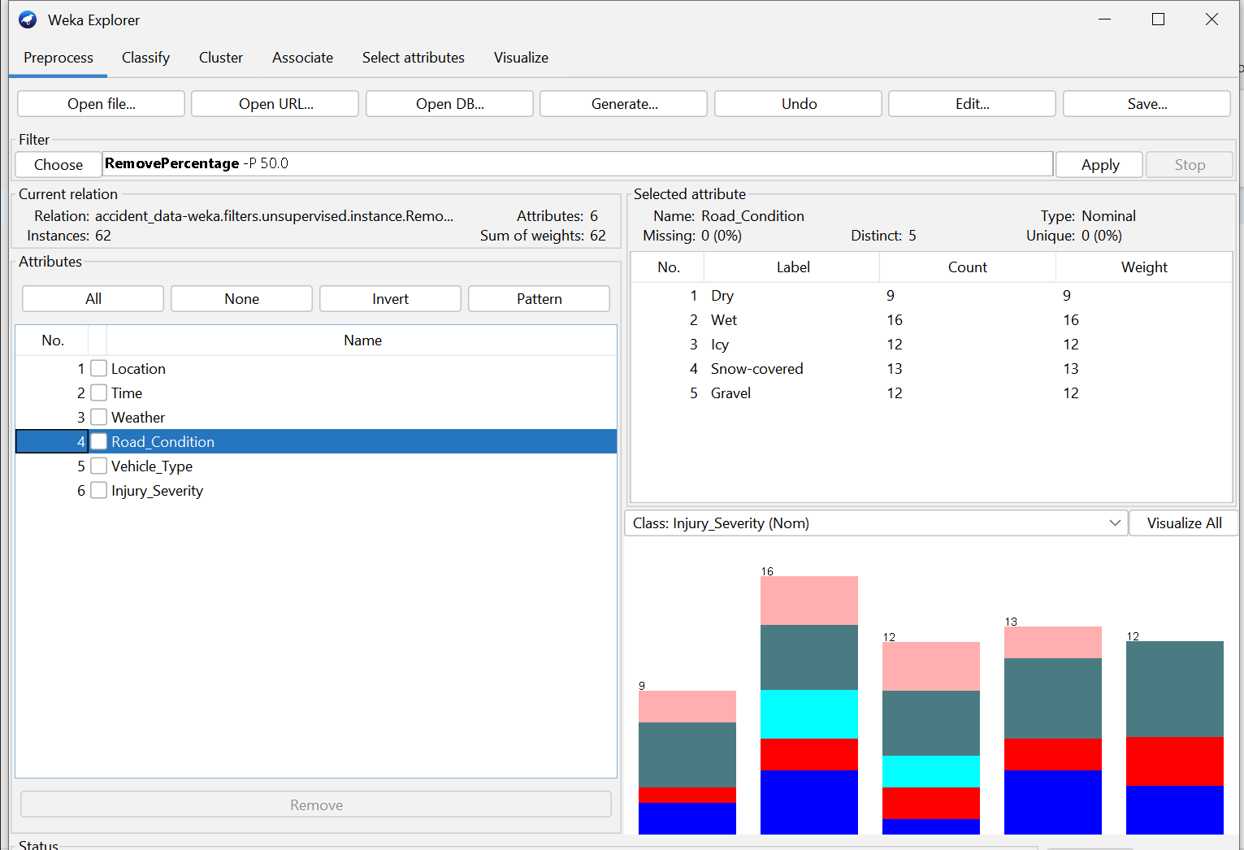

VEHICLE TYPE

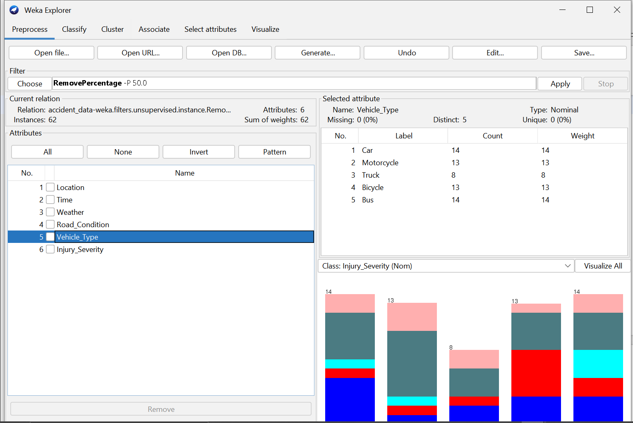

INJURY SEVERITY

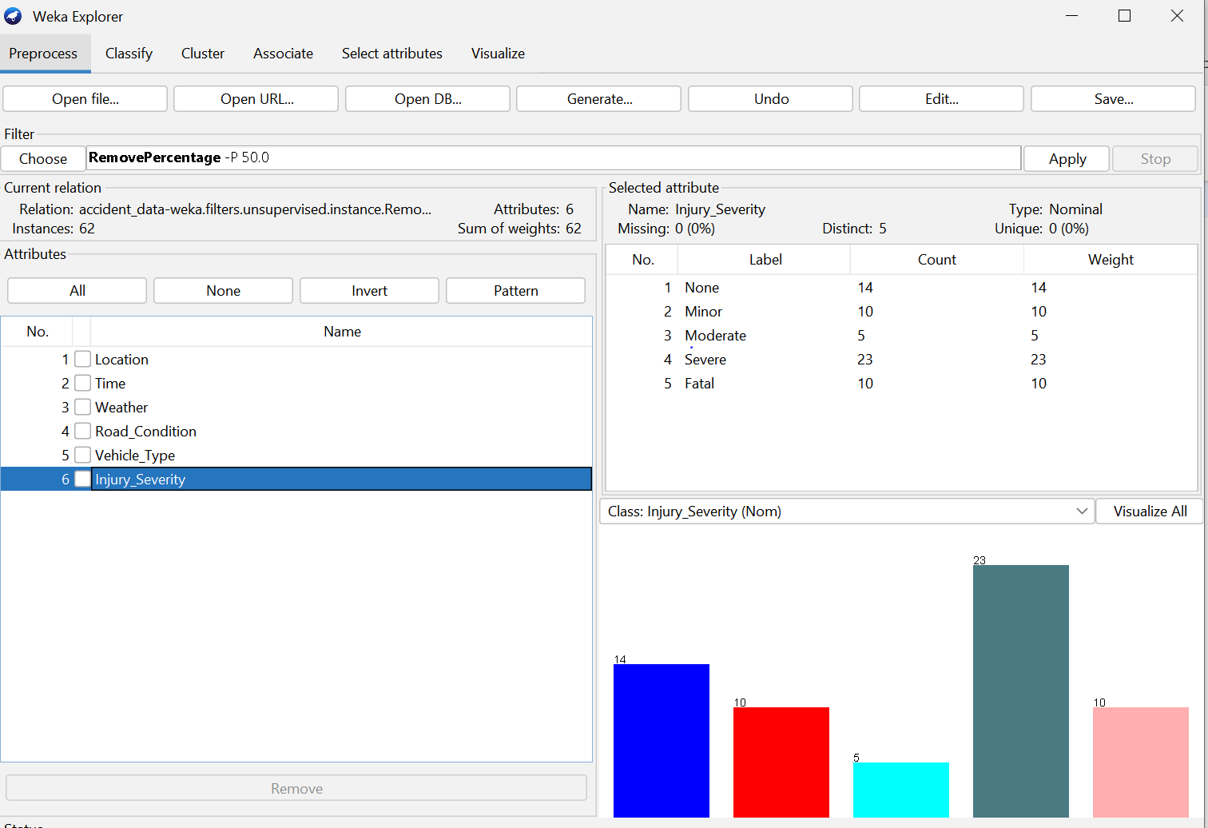

CLASSIFYING

LOCATION

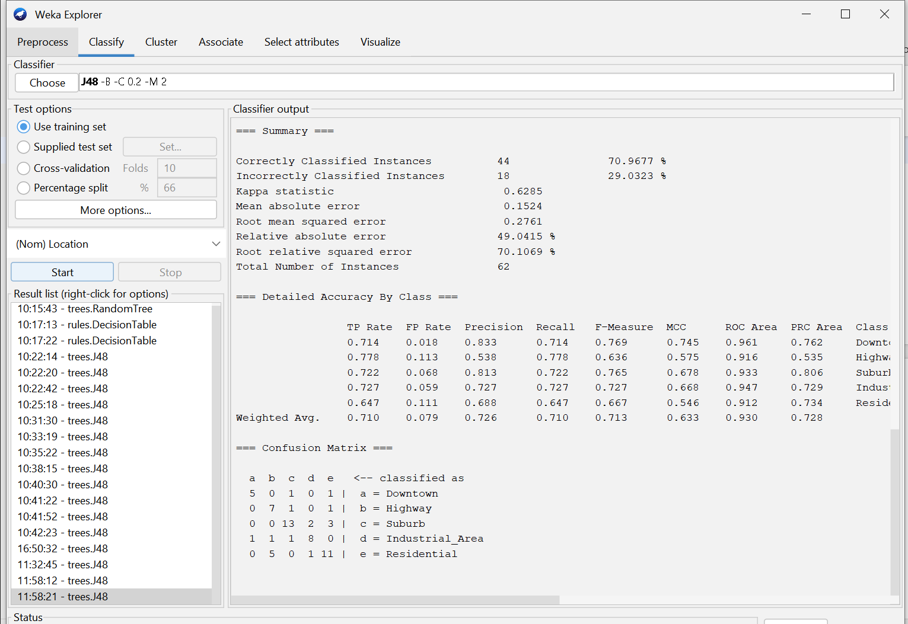

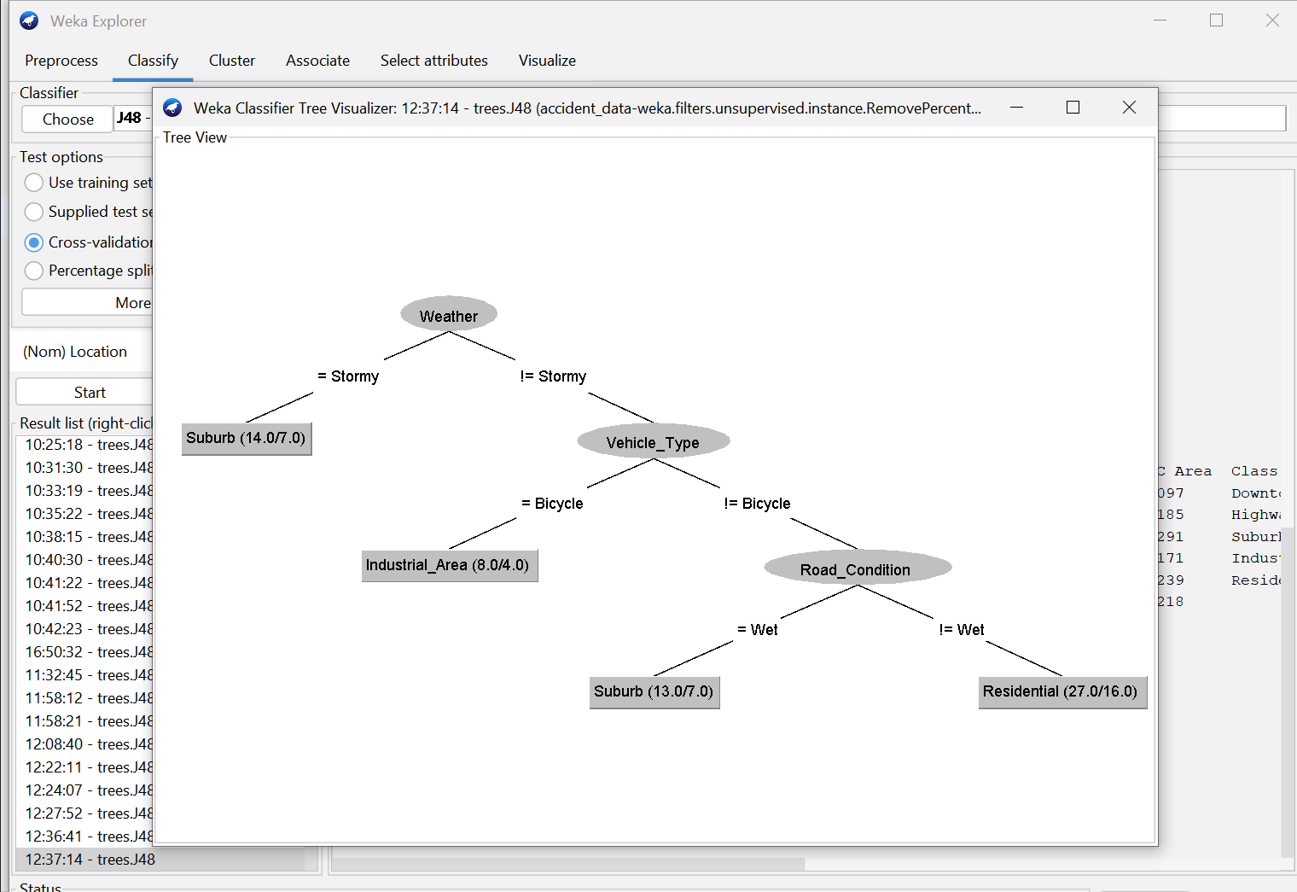

TIME

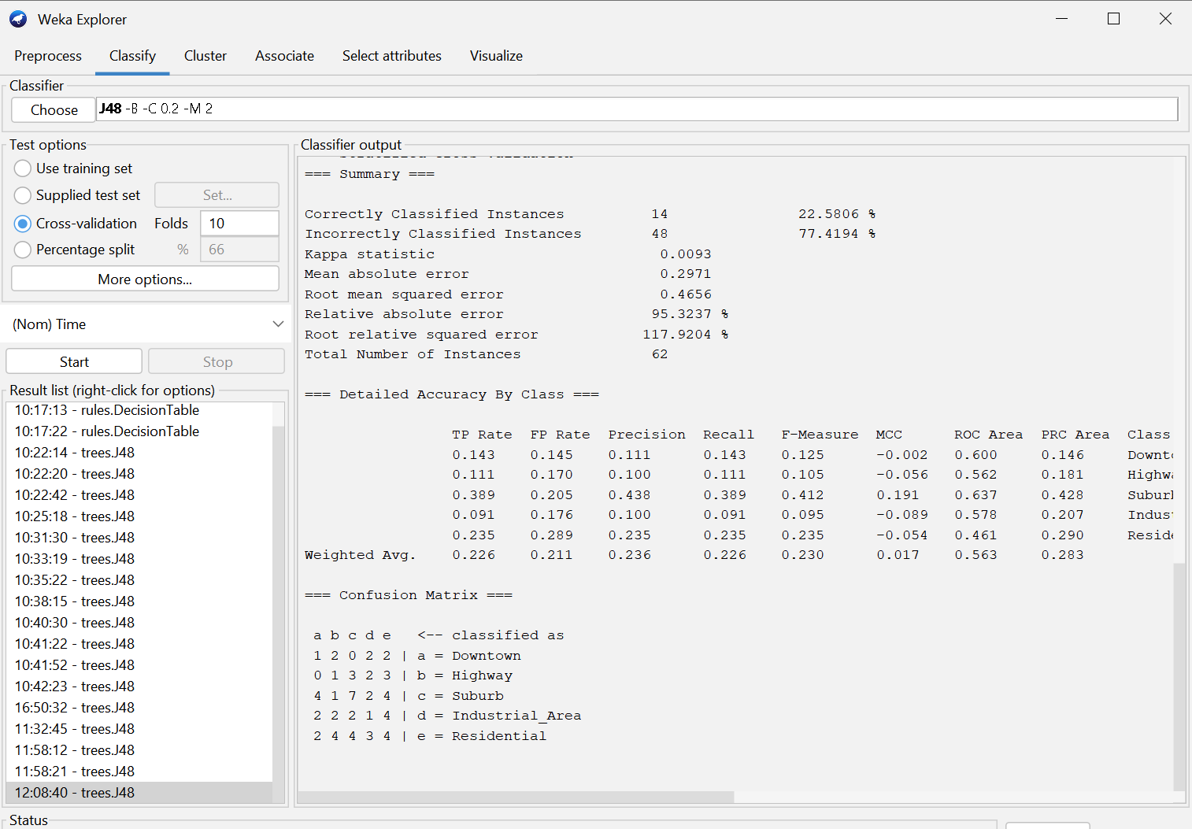

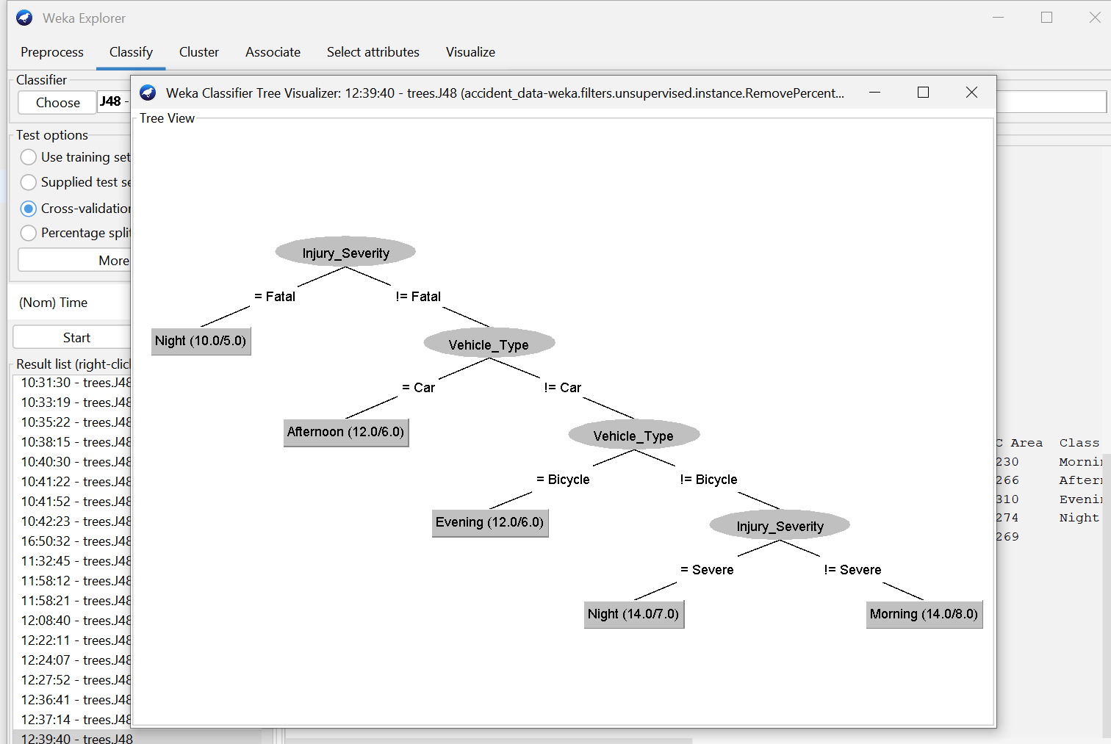

WEATHER

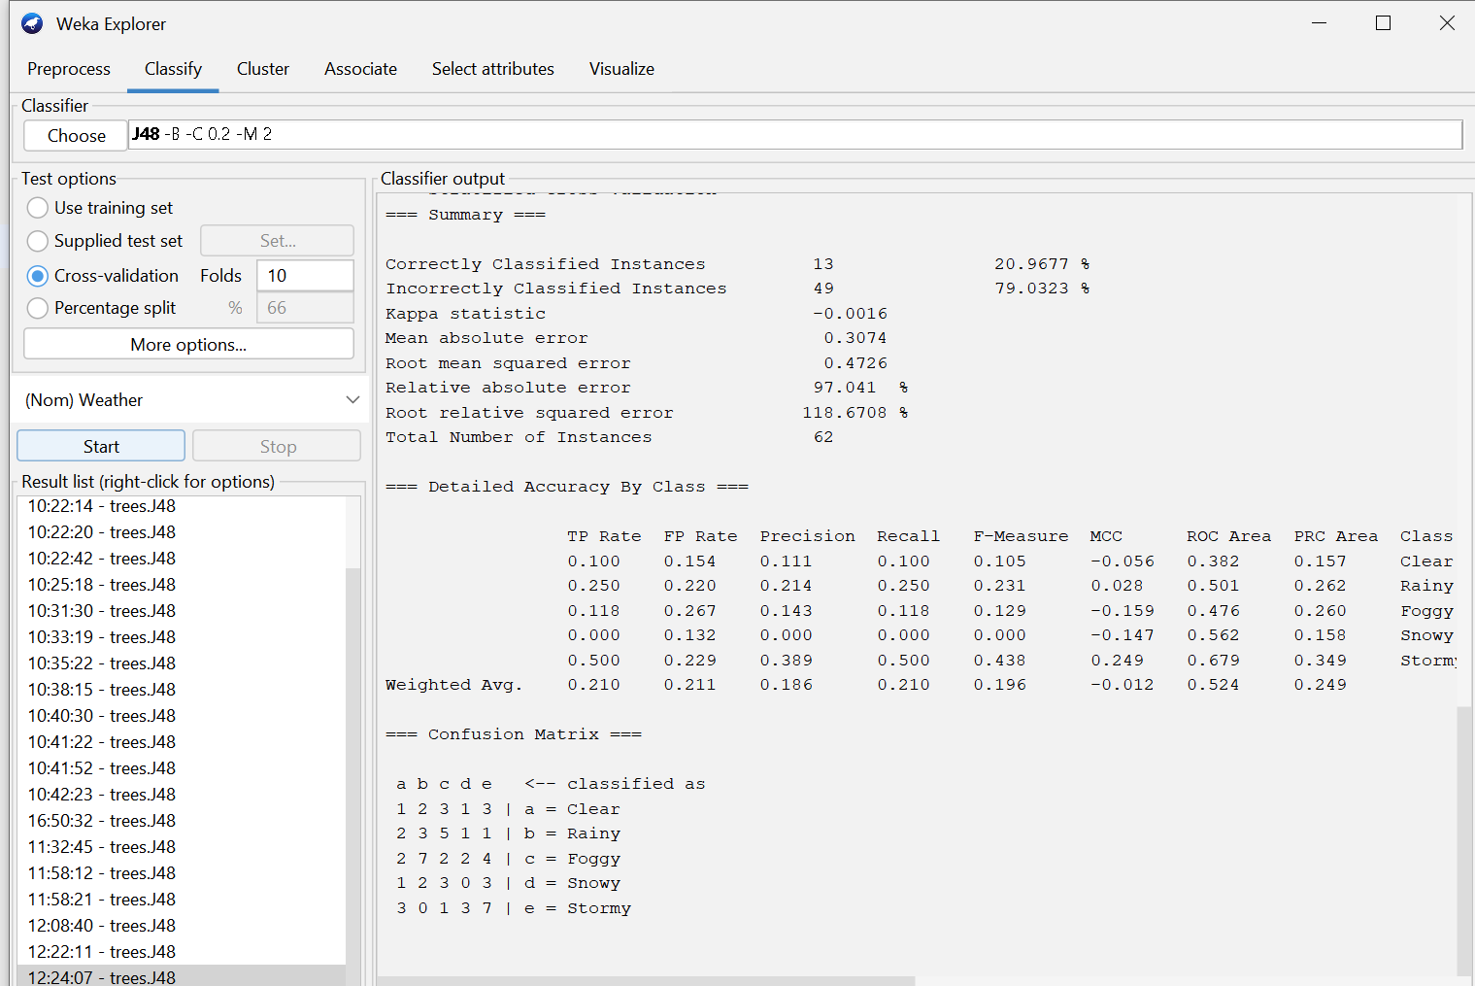

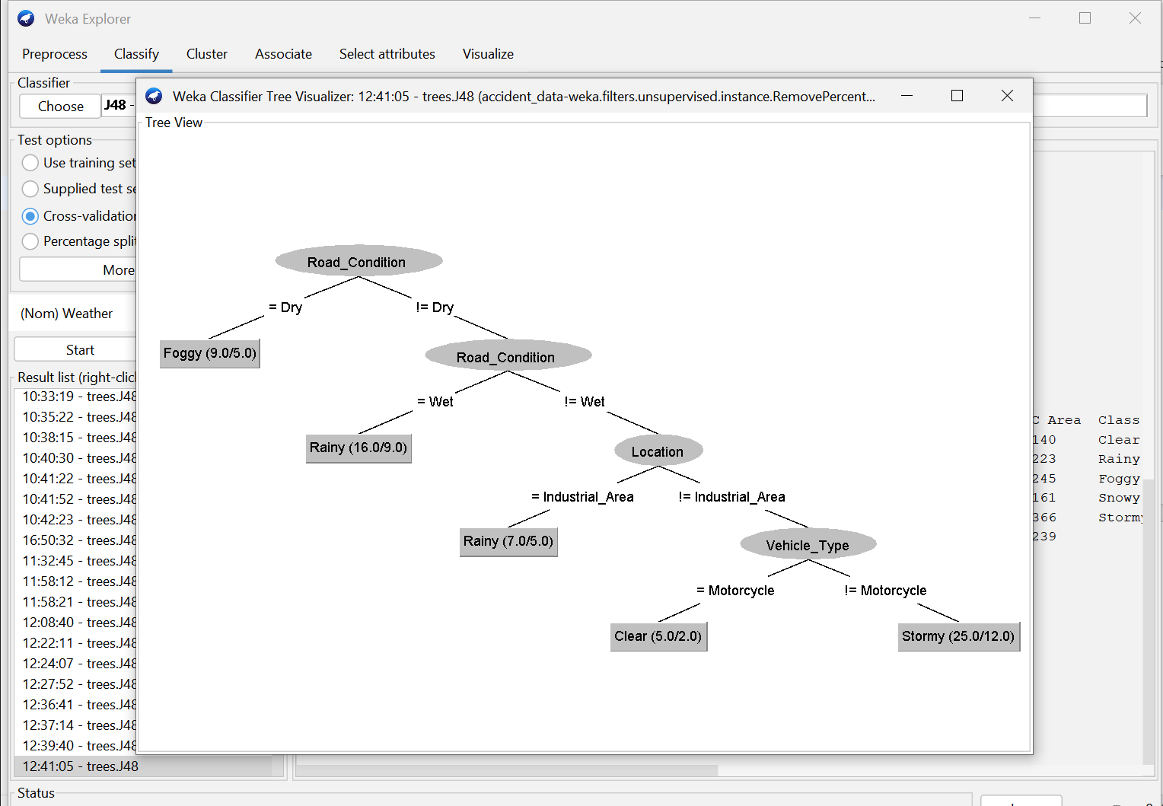

ROAD CONDITION

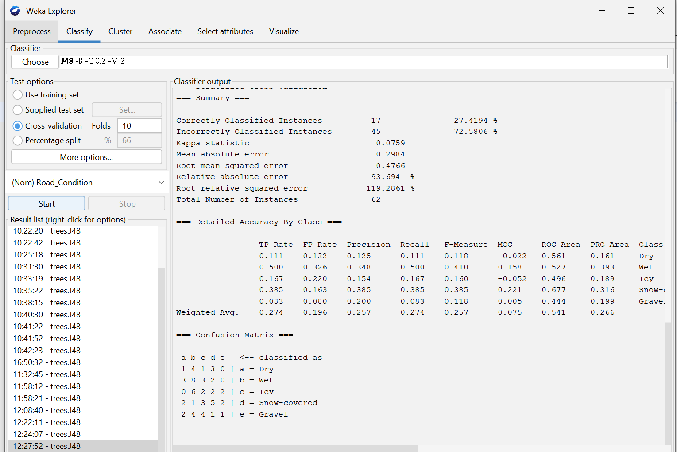

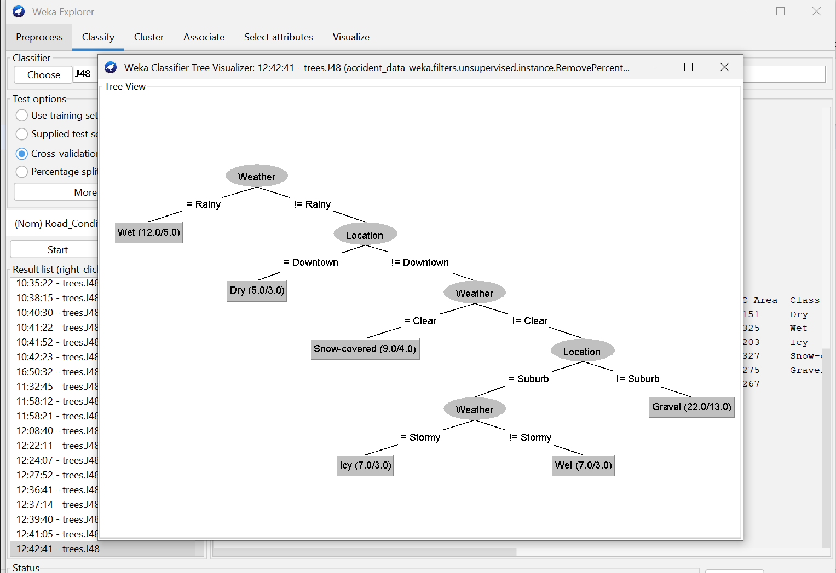

VEHICLE TYPE

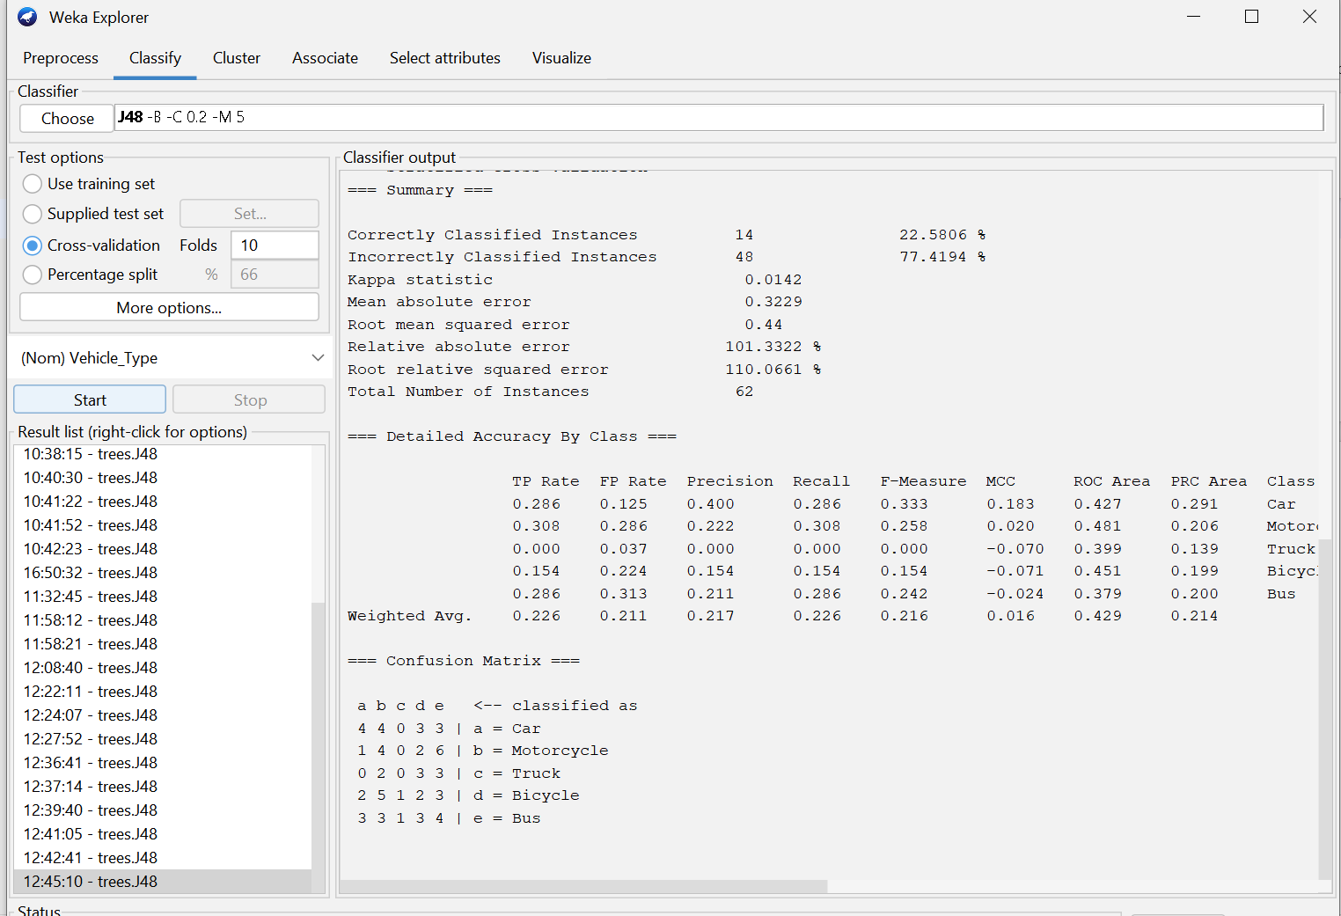

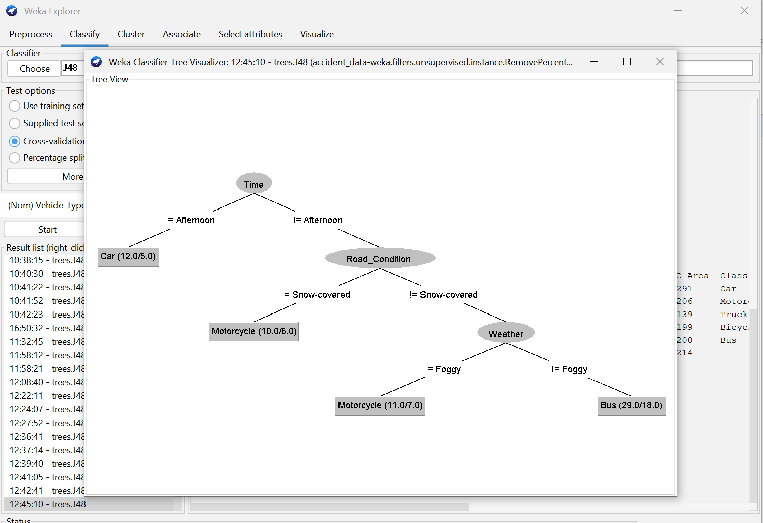

INJURY SEVERITY

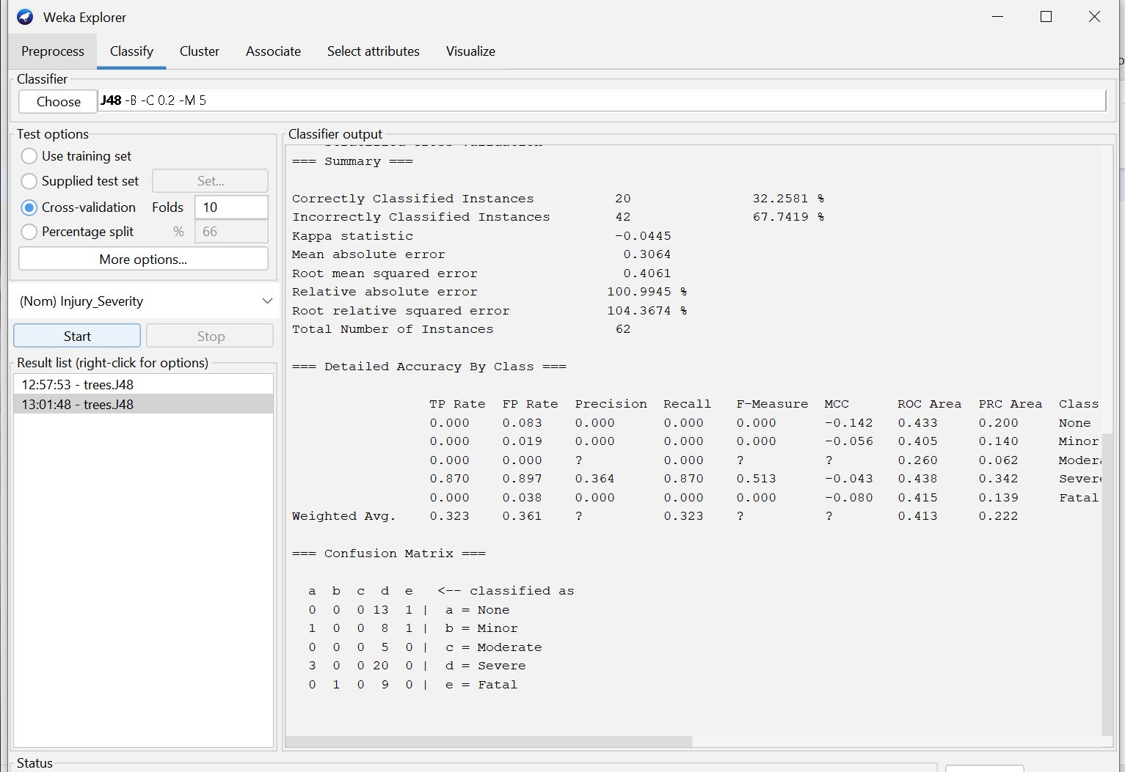

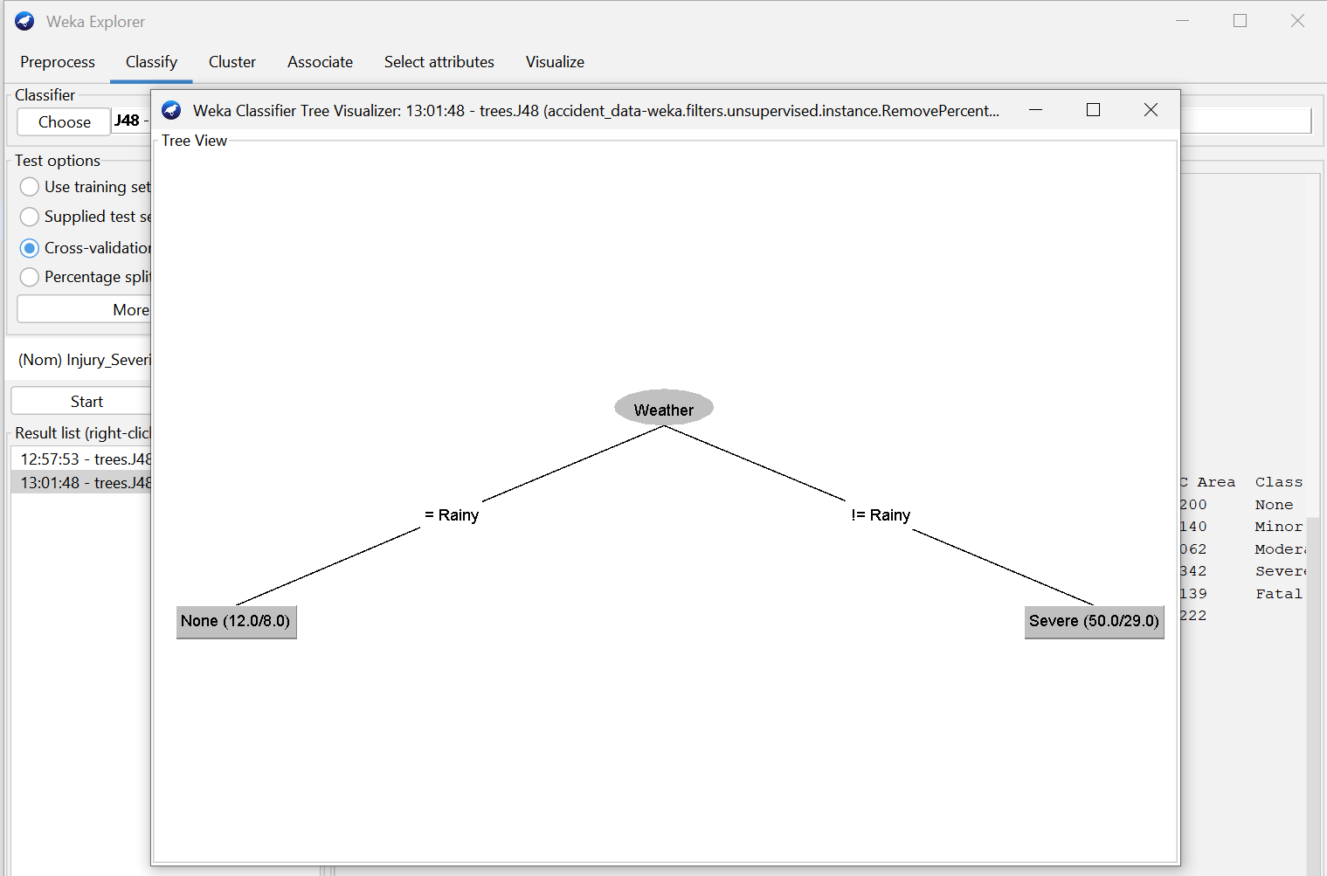

**INSIGHTS**

**1. Primary Contributors to Accidents:**

**Driver-Related Factors:** Behaviors such as risky driving and traffic violations significantly impact accident severity.

**Environmental Conditions:** Adverse weather conditions, like rain, increase the likelihood of accidents due to reduced visibility and slippery roads.

**2. Impact of Road Conditions:**

**Infrastructure Quality:** Poor road conditions, including inadequate lighting and maintenance, contribute to higher accident severity.

**3. Accident blackspot:**

**High-Risk Areas:** Certain locations, such as specific intersections or road segments, exhibit higher accident frequencies, indicating the need for targeted safety interventions.

**4. Vehicle Involvement Trends:**

**Vehicle Types:** The type of vehicle involved in an accident can influence the severity of outcomes, with certain vehicles being more prone to severe accidents.